October 2019 | Briargate Elementary Calendar  Parent Educator: Charlene Spicer-Harmon  Parent Center: 281-634-7759

Upcoming Parent Center Classes

Classes
Monday | Tuesday | Wednesday | Thursday | Friday
 | 1 | 2 | 3 | 4
 | Parent Center Planning and Meetings | Parent Center Connection  8:00a-9:00a | Quarterback and Snacks (HIS)  7:30-8:30a ( Library)  Parent Center Connections  8:30a-9:00a | Parent Center Connection  9:30a-11:00a
7 | 8 | 9 | 10 | 11
Open Computer Use Technology Support  10a-11a |  | Life Skills 10-11a  Parenting Support 3:00-4:00p | Health//Wellness 10-11:30a  Student Early Release | NO SCHOOL
14 | 15 | 16 | 17 | 18
HOLIDAY- NO SCHOOL |  | Life Skills 10-11a  Parenting Support 3:00-4:00p | Bullying Class 8:15a-9:15a  Literacy 2:30p-3:30p Read Aloud Ms. Thompson | Parent Center Connections  9:30a-11:00a
21 | 22 | 23 | 24 | 25
Open Computer Use Technology Support  10a-11a |  | Life Skills 10-11a  Parenting Support 3:00-4:00p | Health//Wellness 10-11:30a Domestic Violence Signs  Literacy 2p-3p | Parent Center Connections  9:30a-11:00a
28 | 29 | 30 | 31 | REMIND APP
Open Computer Use Technology Support  10a-11a |  | Life Skills 10-11a  Health/Wellness (Nurse Cisco) 2p-3p | Health//Wellness 10-11:30a  Literacy 2p-3p | 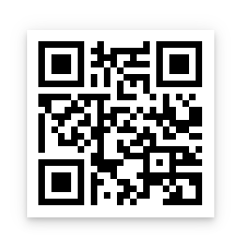  SCAN HERE
- Parent Center Connections: OPEN HOURS for Parents to Visit Parent Center for support
- REMIND APP for Parent Class and Reminders: SCAN CODE TO BE ADDED TO Parent Center Group

